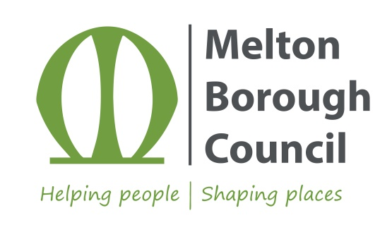
Draft Design Supplementary Planning Document (SPD)
Comments Form

Name:
Job Title (if relevant):
Company (if relevant):
Email:
Telephone number:
Address:

The personal information you give to us will be used for the purpose of this consultation only. We will discard it once the Design SPD has been adopted. If you would like to be notified of the adoption of the Design SPD, please tick here
When submitting comments, please insert the section number (as it appears in the SPD) your comment relates to. The closing date to submit comments is Thursday 22nd July 2021.
Please either scan and email to: planningpolicy@melton.gov.uk or return to: Planning Policy, Melton Borough Council, Council Offices, Parkside, Station Approach, Burton Street, Melton Mowbray, LE13 1GH
1. Introduction and Core Design Principles
2. Working with Nature
3. Making Room for Water
4. Positive Public Spaces
5. Accessible and Legible Streets
6. Locally Distinctive Places
7. Adaptable and Resilient Buildings
8. Major Residential and Mixed Use Developments
9. Minor Residential and Infill Developments
10. Industrial and Commercial Developments
11. Character Notes
12. Residential Parking Guidance
13. Renewable and Low Carbon Energy
14. Residential Separation Distances
15. Any other comments

Thank you very much for your comments. A summary of responses will be reported to Councillors for their consideration, and any appropriate changes made to the draft Design SPD prior to its adoption, which is expected to be in the autumn.

